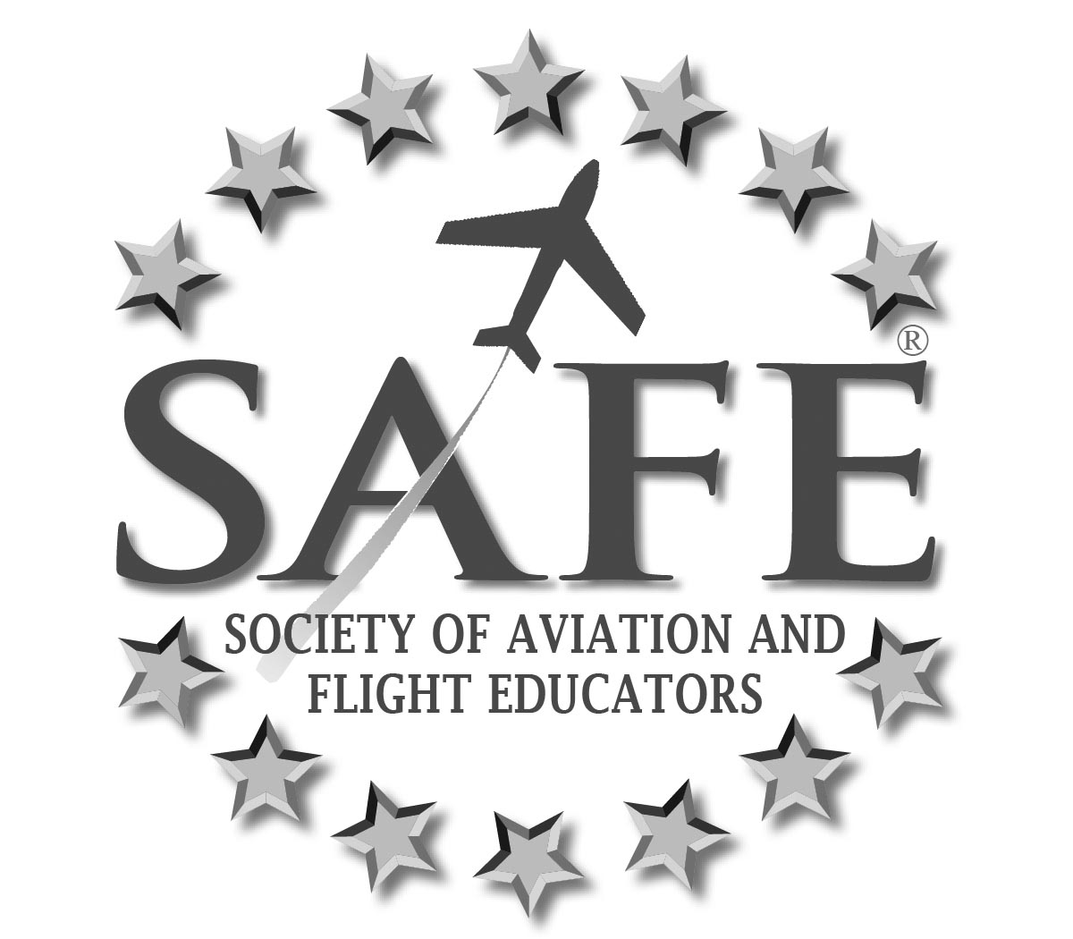

SAFE ACHIEVEMENTS 2009 - 2013

SAFE’s members are highly accomplished people with a lot of valuable experience to transfer
– Former FAA Administrator Randy Babbitt

- Resource Center of member-contributed documents / articles / media, many of these unavailable anywhere else, including simulator scenarios, syllabi and K-12 materials available to the public.
- Developed and conducted the “Pilot Proficiency Project™”, a series of seminars coupled with simulator training scenarios, at AirVenture, SUN ‘N FUN AOPA Summit and the WAI Convention to standing room only audiences. Now presenting weekend events on a quarterly regional basis.
- Needs-based mentoring program developed for all aviation educators.
- Premier CFI liability insurance plan.
- Recipient of three Wolf Aviation Fund grants.
- Chaired the “Pilot Training Reform” Symposium, a landmark event that drew top-tier industry and government stakeholders, promoting and fostering the improvement of aviation safety, reducing the fatal accident rate, and increasing student pilot starts and retention. Now the Pilot Training Reform initiative work is ongoing.
- Partnered with the FAASTeam to create all content for the “Flight Instructor Open Forum” series. Twelve Forums have been delivered to the FAASTeam to date.
- A member of the Airman Testing Standards and Training ARAC.
- A member of the Knowledge Test Aviation Rulemaking Committee.
- The only industry organization invited to present at the Airman Knowledge Testing Program Review Hosted by the Airman Testing Standards Branch, AFS-630.
- Seated on the GAJSC as well as the Statistical Analysis Team and Loss of Control Working Groups of the GAJSC.
- Invited to present at the NTSB General Aviation Safety Forum.
- Consulted with the GAO on their “Initial Pilot Training” study.
- Submitted substantive commentary to NPRMs concerning Pilot Photo IDs, Helicopter Flight Rules, and FIRCs / 61.
- Submitted two reports to FAA based on surveys of SAFE members that have influenced FAA thinking on knowledge testing.
- Impactful presence at major aviation events, including an abundance of SAFE members who habitually present forums during the following events: AirVenture; AOPA Summit; Sun-n-Fun; Women in Aviation.
- Scholarships, Awards, Sponsorship, Fundraisers, Promotion; SAFE member awards program (Founders and Service Awards); $1,000 Scholarship for WAI; Annual K-12 Teacher Grants; Sponsor of the General Aviation Awards Program; P-51 Mustang Flight Fundraising campaign; Communications Quiz headset giveaway.
- Created free training aid, “Teaching MOAs and Restricted Areas” based on SAFE- initiated correspondence seeking clarification from FAA Office of Chief Counsel.
- Working with more than two dozen partners for SAFE member benefits

